Gait Parameter Computation through 2D Human Pose Estimation for Suspect Matching in Crime Identification

|  |
| --- |
| **Author Names1 will go here after a blinded review** |

|  |
| --- |
| Institute of Biomechanics and Orthopaedics, German Sport University Cologne, Cologne, Germany |

Abstract

**KEYWORDS:** gait analysis, human pose estimation.

**INTRODUCTION:** Introduction

* Gait analysis can be used to identify individuals as a biometric marker (Connor & Ross, 2018).
* Especially in forensics, when traditional biometric data like fingerprints or facial recognition are unavailable due to poor quality of surveillance footage.
* Traditional manual annotation methods are highly subjective, labor-intensive and prone to error (Mundt et al., 2024), which opens up the potential to use automated computer vision based solutions like 2D Human Pose Estimation HPE to enhance objectivity.
* Previous studies validate the application of 2D HPE methods to be used for gait parameter calculation in controlled, laboratory conditions and good image quality (Stenum et al., 2021).
* However translating these results into uncontrolled environments and real life situations remains challenging, as the accuracy for extracting gait parameters depends on variable conditions like varying angles, resolution, clothing and occlusions (Cormier et al., 2022)​.
* This highlights a gap where procedures need to be tested in realistic surveillance conditions
* This brings me to the primary focus of this paper, which is whether 2D HPE techniques can reliably measure distinct gait angles - specifically ankle dorsiflexion, knee flexion, knee adduction, and hip flexion - at touchdown (TD) and toe-off (TO) to serve as valid biometric markers under real-world surveillance conditions.

**METHODS:** Methods

* 14 Participants (11m, 3f) (dropouts?)
* Two subsequent measurements 3D Motion Capture (MoCap) as valid reference and 2D HPE
* It had to be two measurements because loose clothing of the real-world condition would obscure the 3D MoCap markers
* In both conditions the participants walked on a predefined path and maintained a speed that was between 1.65 and 1.75 m/s, which was controlled by timing gaits.
* 3D MoCap data was recorded by 14 infrared cameras (Qualisys, Gothenburg, Sweden, 200 Hz) with lower body marker set of 28 reflective markers
* 2D setup was conducted afterwards with 2 (4) go pro (Hero 6) cameras sagittal and frontal to the walking path.
* All participants wore loose clothing and facemasks to hide their identity and offer a realistic crime scene condition
* For processing of mocap data the gait parameter angle computation was conducted using AnyBody model with static reference trial to establish neutral anthropometric baseline angles …..
* The processing of the 2D data was done in the following steps
* First the raw video material was analysed using OpenPose (Cao et al., 2019)​ and AlphaPose (Fang et al., 2022), which outputted specific anatomical landmarks called keypoints for all individuals in the field of view
* To maintain continuous tracking and to correct any mislabelling, a tool was developed similar to Stenum et al., 2021, to achieve consistent and valid tracking
* In a next step the trajectories were filtered using a zero-lag 4th order low-pass Butterworth filter with a cut-off frequency of 5 Hz as proposed by Stenum et al., 2021.
* Angles were calculated in 2D using simple trigonometry, following the International Society of Biomechanics (ISB) recommendations for joint coordinate systems (JCS) (Wu & Cavanagh, 1995) and Grood and Suntay's (1983) Joint Coordinate System for the knee joint (Grood & Suntay, 1983)
* No additional anthropometric adjustments were applied reflecting realistic forensic scenarios
* Four distinct angles–ankle dorsiflexion, knee flexion, knee adduction and hip flexion– were calculated for TD and TO and for every participant across multiple steps the mean was calculated to generate a distinct biometric measure.
* For the statistical analysis a paired t-test between MoCap reference and HPE angles was conducted to study differences
* Also a Bland-Altman analysis (Bland & Altman, 1986)​ was used to assess agreement and to identify systematic biases. Confidence interval (CI) and Limits of Agreement (LoA) were used to quantify the reliability of the new method and its applicability for forensics. Here also the intrasubject variability (IV), which is the range in observed angles over all participants by the MoCap method.

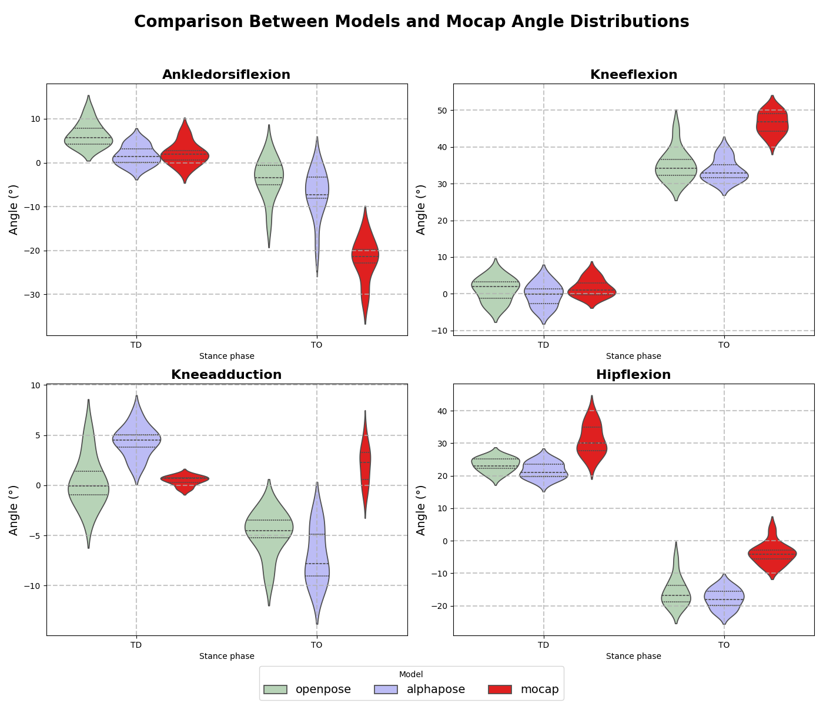

**RESULTS:** Results

* Evaluation of the accuracy of gait parameters extracted using OpenPose and AlphaPose relative to 3D MoCap as a reference measure
* Paired t-test showed significant differences between MoCap and HPE models for most parameters. What can also be observed in figure X(violin)
* Exceptions were TD knee flexion and TD knee adduction for OpenPose (p>0.01) and TD ankle dorsiflexion for AlphaPose (p>0.01) (Here I find it hard to find a value that is representative for the “difference” or no difference)
* Also, systematic discrepancies can be observed and are also strengthened by the calculated bias. Where for ankle dorsiflexion at TO both models overestimate (recheck) relative to MoCap (bias: AlphaPose =+12.66°; OpenPose=+16.34°). For knee flexion at TO both models consistently underestimate (bias: AlphaPose =-13.62°; OpenPose=-11.73°). Knee adduction at TO for both models is underestimated (bias: AlphaPose=-9.14°; OpenPose=-6.79°). Hip flexion is consistently underestimated by both models for TD (bias: AlphaPose=-9.26°; OpenPose= -7.60°) and for TO (bias: AlphaPose=-14.86°; OpenPose=-12.56°). (Do all results need to be put in words here?)
* Almost all CI were observed to be greater than the IV of the Mocap parameters except for TD ankle dorsiflexion of AlphaPose (CI: 8.312°; IV: 8.70°).

**CONCLUSION:** Conclusion

* Bridging the gap was leite ich ab und was müsste noch passieren um die methode verwenden zu können

**REFERENCES:**

* Bland, J. M., & Altman, D. G. (1986). Statistical methods for assessing agreement between two methods of clinical measurement. The Lancet, 327(8476), 307–310. https://doi.org/10.1016/S0140-6736(86)90837-8
* Cao, Z., Hidalgo, G., Simon, T., Wei, S.-E., & Sheikh, Y. (2019). OpenPose: Realtime multi-person 2D pose estimation using part affinity fields. IEEE Transactions on Pattern Analysis and Machine Intelligence. Advance online publication. https://doi.org/10.1109/TPAMI.2019.2929257
* Connor, P., & Ross, A. (2018). Biometric recognition by gait: A survey of modalities and features. Computer Vision and Image Understanding, 167, 1–27. https://doi.org/10.1016/j.cviu.2018.01.007
* Cormier, M., Clepe, A., Specker, A., & Beyerer, J. (2022). Where are we with human pose estimation in real-world surveillance? In 2022 IEEE Winter Applications of Computer Vision Workshops (WACVW) (pp. 1591–1600). IEEE. https://doi.org/10.1109/WACVW54805.2022.00065
* Fang, H.-S., Li, J., Tang, H., Xu, C., & Zhu, H. (2022). AlphaPose: Whole-body regional multi-person pose estimation and tracking in real-time. IEEE Transactions on Pattern Analysis and Machine Intelligence. Advance online publication. <https://doi.org/10.48550/arXiv.2211.03375>
* Grood, E. S., & Suntay, W. J. (1983). A joint coordinate system for the clinical description of three-dimensional motions: Application to the knee. Journal of Biomechanical Engineering, 105(2), 136–144. https://doi.org/10.1115/1.3138397
* Mundt, M., Colyer, S. L., Wade, L., Needham, L., Evans, M., Millett, E., & Alderson, J. (2024). Automating video-based two-dimensional motion analysis in sport? Implications for gait event detection, pose estimation, and performance parameter analysis. Scandinavian Journal of Medicine & Science in Sports, 34(1), e14693. https://doi.org/10.1111/sms.14693
* Stenum, J., Rossi, C., & Roemmich, R. T. (2021). Two-dimensional video-based analysis of human gait using pose estimation. PLOS Computational Biology, 17(4), e1008935. https://doi.org/10.1371/journal.pcbi.1008935
* Wu, G., Cavanagh, P. R., & Standardization and Terminology Committee of the International Society of Biomechanics. (2002). ISB recommendation on definitions of joint coordinate system of various joints for the reporting of human joint motion—Part I: Ankle, hip, and spine. Journal of Biomechanics, 35(4), 543–548. https://doi.org/10.1016/S0021-9290(01)00222-6

Birch et al 2013 The identifivation of individuals….

Stenum et al 2021 Two dimensional video based analysis…

Cormier et al 2022 Pose Estimation in real world surveillance…

Fang et al 2022 Alphapose

Cao et al 2019 Openpose

Grood and Suntay's (1983) Joint Coordinate System for the knee joint (Grood & Suntay, 1983)